**MicroRNA Biomarkers for Preeclampsia at 28 weeks Gestation**

**Grant recipients:** Dr Carole-Anne Whigham,Dr Tu’uhevaha Kaitu’u-Lino, Dr Teresa MacDonald

**FINAL REPORT March 2019**

Preeclampsia (PE) is a hypertensive disorder of pregnancy that is a major cause of both maternal and fetal morbidity and mortality throughout the world. It is characterized by poor placental implantation and release of placental factors into the maternal circulation. These placental factors cause dysfunction of the cells that line maternal blood vessels leading to end organ damage and the clinical complications of preeclampsia. At present, there is no way to predict who will develop preeclampsia. A predictive test would allow safe triage of antenatal surveillance strategies, implementation of closer monitoring where needed, and treatment to help alleviate the tragic impact of the disease.

MicroRNAs (miRs) are small (~20 nucleotides) non-coding RNAs that are highly stable in the circulation as they are not readily broken down. They regulate gene expression and distant cell signaling. There is growing interest in the use of miRs as predictive biomarkers of disease, particularly in the cancer field. We hope their potential might also be realised as predictive biomarkers of preeclampsia.

The Fetal Longitudinal of Growth Study (FLAG) involved prospectively taking blood samples from ~2000 women at 28 and 36 weeks’ gestation. These pregnancies were characterized and some of these women were found to develop PE later in their pregnancies. Therefore, we have a cohort of blood samples from patients who are destined to develop PE which allows us to evaluate the predictive value of miRNA biomarkers at 28 weeks of gestation.

**SUMMARY OF PROGRESS:**

We are pleased to report this project is now completed.

**Aim 1:**

Identify the differentially expressed miRs in PE by carrying out a microarray to measure the expression of 41 placenta-specific miRs.

We are pleased to report we have completed the microRNA microarray on the 335 samples, including 37 preceding preeclampsia compared with control. Of the 41 microRNAs that were investigated, we found 6 were significantly altered in the patient samples who were destined to develop preeclampsia. We have also progressed to look these altered microRNAs in the circulation of patients with established early onset preeclampsia compared with control, and in the placentas of patients with established early onset preeclampsia compared with control.

**Excitingly, we have found that miR 363 is significantly altered in all three of these cohorts.**

Figure 1: miR 363 expression is reduced at 28 weeks in the blood of women who are destined to develop late onset preeclampsia. It is also significantly reduced in the blood of women with established early onset preeclampsia and in the placentas of women with severe, early onset preeclampsia.



**28 Week FLAG**



**Established PE**



**Placentas**

**Aim 2:**

Validate our findings and determine test performance by measuring the differentially expressed miRs among all of the first 1000 FLAG participants.

We have now completed this aim. We performed a standard curve for miR363 to investigate the usefulness of miR363 in detecting preeclampsia on a population basis. We measured it in the first 1000 FLAG samples.

We found that that there was no significant difference in miR363 in this group.

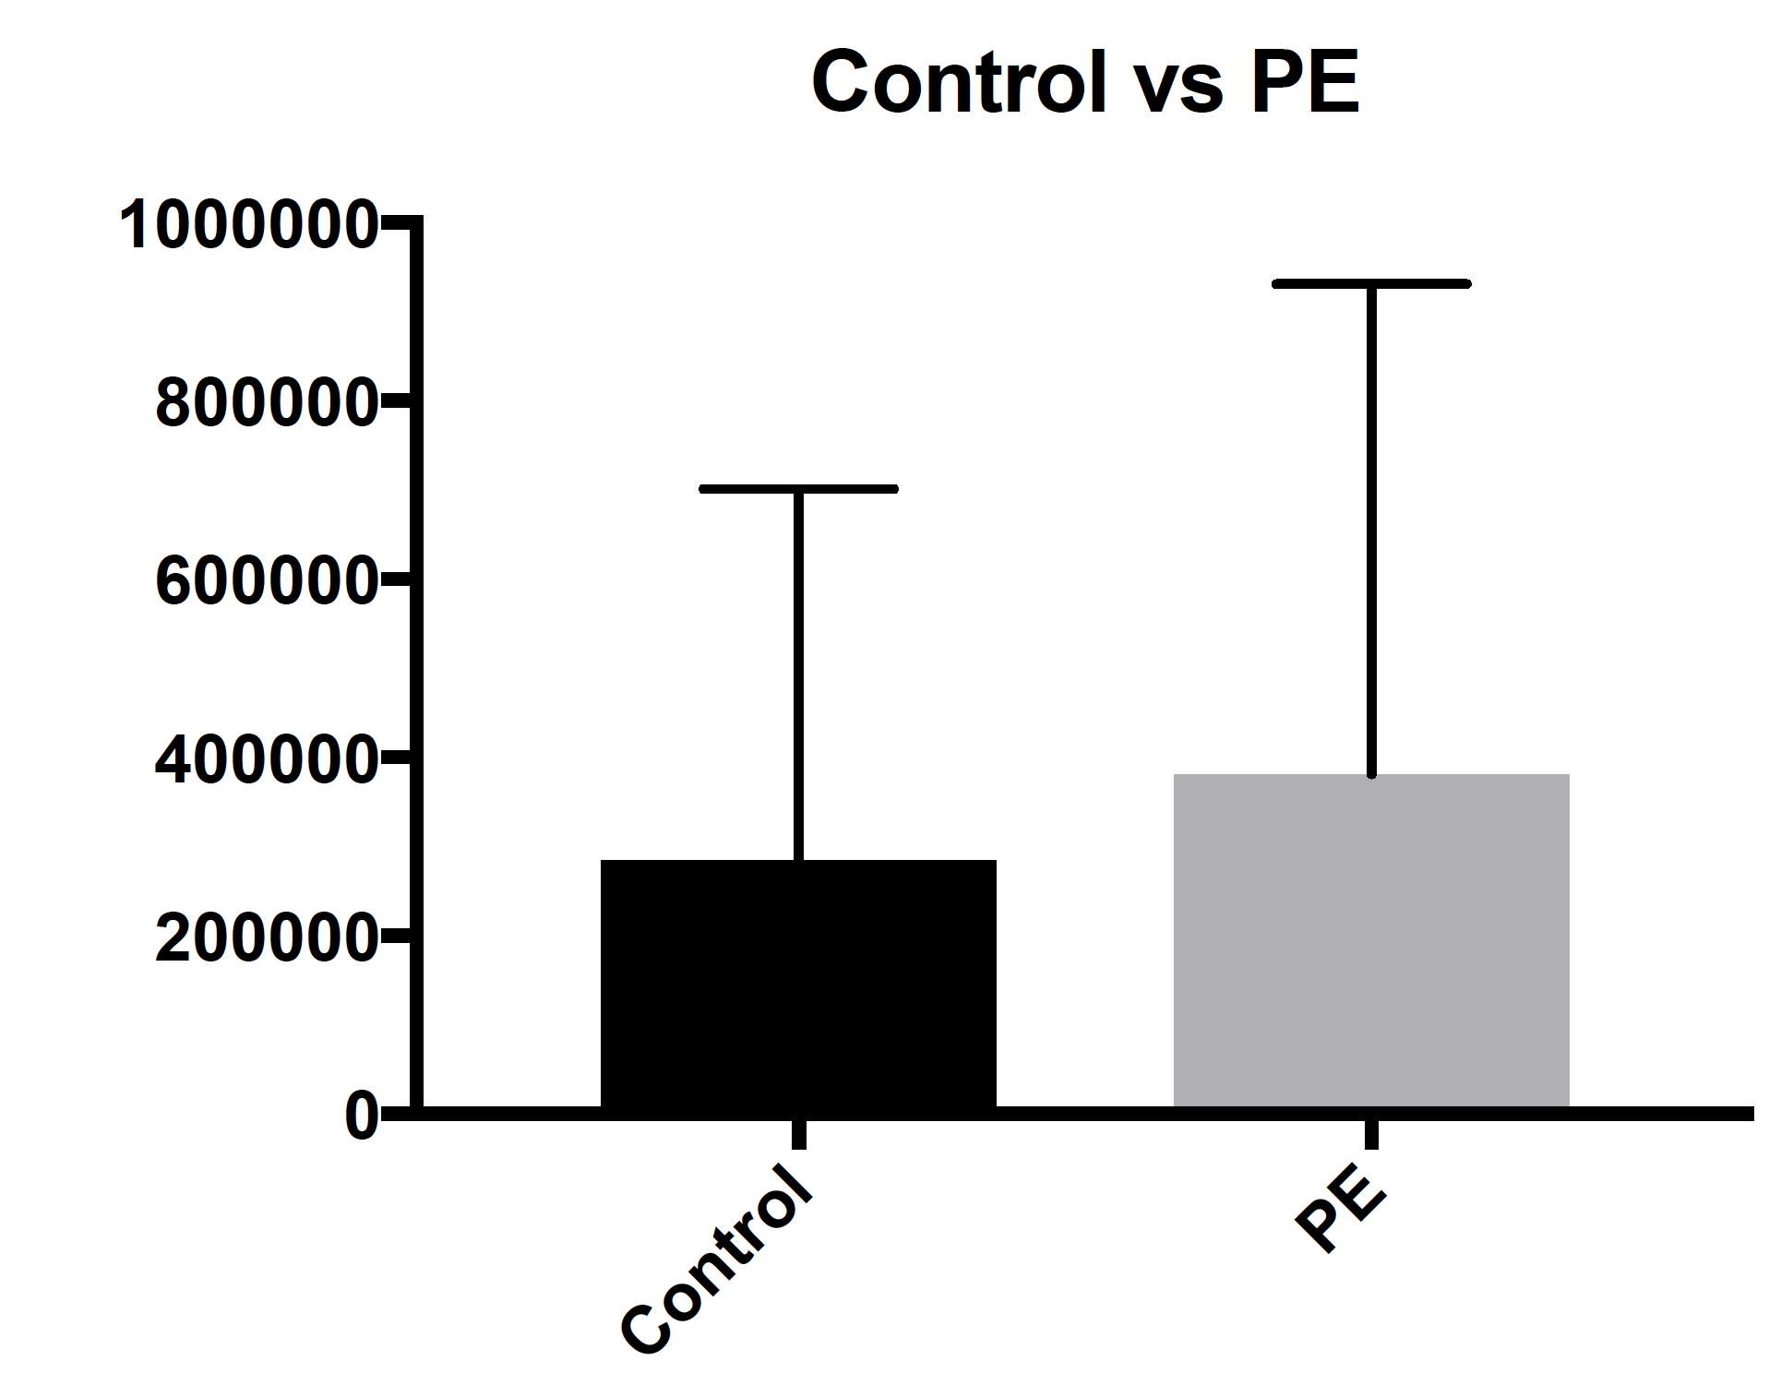

Figure 2: there was no significant difference in miR363 expression when comparing controls and preeclamptic samples in the first 1000 FLAG participants.

**Conclusion:**

We have now undertaken validation studies for miR 363 in the first 1000 FLAG samples. Although we found no significant difference between preeclampsia and controls in this cohort, our results from aim 1 are very exciting and highly publishable. We are now preparing the manuscript for publication.