Validating mRNA biomarkers to predict fetal growth restriction
Grant recipients: Dr Tu’uhevaha Kaitu’u-Lino, Dr Teresa MacDonald, Professor Susan Walker, Professor Stephen Tong
FINAL REPORT March 2019
Corresponding applicant: Dr Kaitu’u-Lino: Melbourne University Department of Obstetrics and Gynaecology, Mercy Hospital for Women. 163 Studley Rd., Heidelberg 3084. Ph: 0414541609 or 8458 4355. Email: t.klino@unimelb.edu.au
SYNOPSIS OF THIS GRANT:
Fetal growth restriction (FGR) is the failure of a fetus to reach its genetically pre-determined growth potential. The major contributor to FGR is placental insufficiency¹ where the placenta fails to provide adequate nutrition and oxygen to the growing fetus. It is the leading cause of stillbirth, a tragedy impacting 1:130 pregnancies in Australia. Our ability to reduce the burden of stillbirth is limited by the poor sensitivity and specificity of current screening tools available to detect small babies in utero.
The Fetal Longitudinal Assessment of Growth (FLAG) study is a study involving over 2000 women who had blood samples taken at 28 and 36 weeks’ gestation. The aim of the FLAG study was to examine the predictive ability of genetic markers (mRNA) released from the placenta into maternal blood to predict term FGR. Of the 2000 women, 10.5% subsequently delivered a small baby, with birthweight <10th centile (Small for gestational age, SGA which is a population that will be enriched for FGR babies). Utilising blood samples already collected as part of the FLAG study, we have identified promising ‘genetic signatures’ that appear to perform well predicting the small baby. This research proposal aims to validate these novel placenta-specific genes using a technique which is more advanced, more sensitive, and clinically useful known as digital PCR. In addition, we will further continue our discovery for other mRNA biomarkers.
SUMMARY OF PROGRESS:
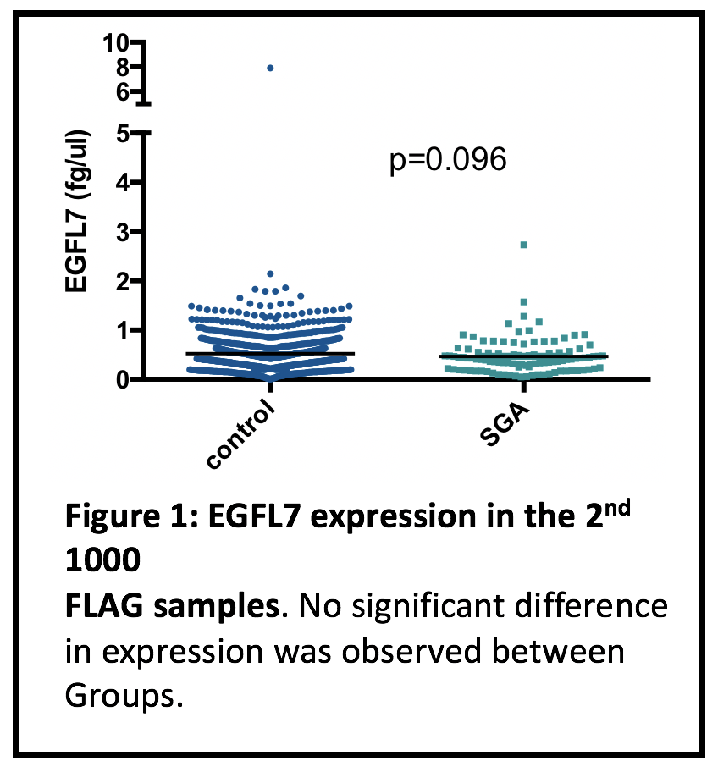
We are pleased to report that this project has now completed.
Aim 1. To validate 4 genes discovered in the case/control cohort in the first 1000 FLAG samples
We are pleased to report that we have completed aim 1 of this project. During the course of the last 6 months, after liaising with Life Technologies and Thermo Fisher, we concluded that the best way to validate our 4 genes was using a standard curve technique. This allows us to determine the exact amount of mRNA specific to our genes of interest within our clinical samples. In the first 1000 samples, we did not identify any significant changes, however there was a strong trend towards one gene, EGFL7 being significantly lower in the circulation of women who subsequently delivered an SGA baby. Given this find, we decided to measure EGFL7 in the entire 2nd 1000 samples (Figure 1). Within the 2nd 1000 however, we found no significant difference between groups.
Aim 2) To continue our discovery by measuring the remaining PSGs in a case/control cohort of FLAG samples
Aim 2 is also now complete for this project. Rather than screening the remaining Placental Specific Genes (PSGs) one by one as proposed, we decided to use a new and exciting platform technology offered by Qiagen. This technology is called 3’UPX Transcriptome Analysis. This new technology allows us to identify any genes within the entire genome that are differentially expressed within the blood of women who are destined to deliver a small baby. Our samples were sent to Qiagen headquarters in the US and the sequencing undertaken.
Excitingly, we have now completed the analysis which has revealed a list of 20 genes that are significantly altered in the blood of women preceding their delivery of a small baby. We are now making plans to validate these results in the larger FLAG cohort.

Conclusion
We have now undertaken validation studies for genes that we had picked as significantly different in our case control cohort. Although we did not find any significant changes when we measured these genes in the entire first 1000 (and 2nd 1000 for EGFL7) FLAG samples, we are very excited that the 3’ UPX sequencing has revealed a new set of 20 genes that are differentially regulated in the blood of women preceding their delivery of a small baby. We are now making plans to validate this work via qRT-PCR.

